River Raid in 45 minutes

It’s not a speed-run, it’s speed-coding

Krzysiek D.
Phaser library
https://cdn.jsdelivr.net/npm/phaser@3/dist/phaser.js

Page setup
<html>
<head><script src="phaser.min.js"></script></head>
<body>
<div id="game-container"></div>
</body>
<script></script>
</html>

Crucial methods of a Game
function preload(){
}

function create(){
}

function update(){
}

Phaser setup
const config = {
type: Phaser.CANVAS,
width: 800,
height: 600,
parent: 'game-container',
scene: {
preload: preload,
create: create,
update: update
}
};

Start
const game = new Phaser.Game(config);

(Pre)loading pictures
function preload(){
this.load.image('background', 'empty-project/board.png');
this.load.image('aircraft', 'empty-project/aircraft.png');
this.load.image('boat', 'empty-project/enemy.png');
this.load.image('bullet', 'empty-project/bullet.png');
}

Creating sprites
let background;
let player;
let bullet;
const boatsCount = 3;
let boats = [];
let cursors;
let fire = false;
function create(){
background = this.add.sprite(400, -1500 + 600, 'background');//pic size: 800x3000

const boatcoords = [[210,-10, 0.2], [151,-320, 0.3], [0,-510, 0.5]];
for (let i = 0; i < boatsCount; i++){
let b = this.add.sprite(boatcoords[i][0], boatcoords[i][1], 'boat');
b.speed = boatcoords[i][2];
b.active = true;
boats.push(b);
}
bullet = this.add.sprite(300, 550+15, 'bullet');
player = this.add.sprite(300, 550, 'aircraft');
cursors = this.input.keyboard.createCursorKeys();

Background move
Background collision
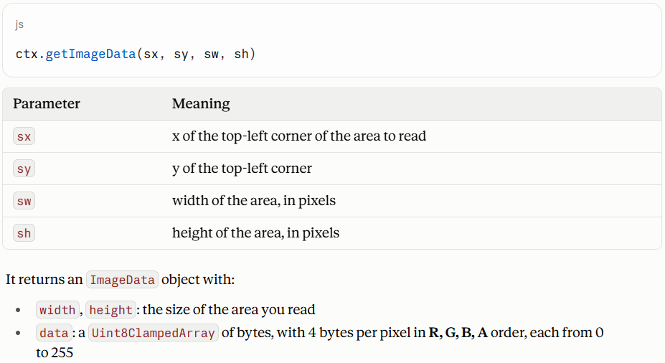
function update(time, delta){
background.y += 1;

function checkBackgroundCollision(){
const ctx = game.canvas.getContext('2d');
const leftTopPixel = ctx.getImageData(player.x - Math.floor(79/2), 600-50, 1, 1).data;
const rightTopPixel = ctx.getImageData(player.x + Math.floor(79/2), 600-50, 1, 1).data;
const groundColor = [136, 0, 21];
const riverColor = [63, 72, 204];
const pixelsToCheck = [leftTopPixel, rightTopPixel];
pixelsToCheck.forEach(pixelColor =>{
if (pixelColor[0] === groundColor[0] && pixelColor[1] === groundColor[1] && pixelColor[2] === groundColor[2])
gameOver();
});
}
function gameOver(){
window.alert('GAME OVER!');
location.reload();
}

function checkKeys(){
const speed = 4;
if (cursors.left.isDown){
player.x -= speed;
bullet.x -= speed;
} else if (cursors.right.isDown){
player.x += speed;
bullet.x += speed;
}
if (cursors.up.isDown){
fire = true;
}
}

function moveBoats(){
for(let i = 0; i < boatsCount; i++){
if (!boats[i].active)
continue;
boats[i].x += boats[i].speed;
boats[i].y++;
}
}
function fireConditionally(){
if (fire){
if (bullet.y>0){
bullet.y -=6;
checkCollision();
}
else{
resetBullet();
}
}
}
function checkCollision(){
for(let i = 0; i < boatsCount; i++){
if (boats[i].active){
const d = Phaser.Math.Distance.Between(boats[i].x + 136/4, boats[i].y, bullet.x, bullet.y);
console.log(i, d);
if (d < 40){
boats[i].y = Math.pow(10,16);
boats[i].active = false;
resetBullet();
}
}//end if active
}//end for
}
function resetBullet(){
fire = false;
bullet.y = 550 + 15;
}

function update(){
background.y += 1;
checkBackgroundCollision();
checkKeys();
moveBoats();
checkCollision();
fireConditionally();
}

